**When an account owner logs into their account, they’ll have a column of actions on the left-hand side of their profile page. Underneath “recurring contributions”, they should see “view and invite savings with Ugift”**

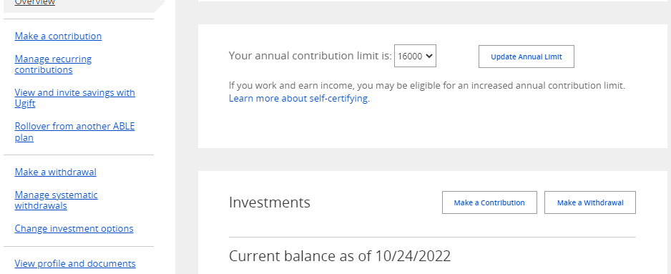

**If they click this option, it will bring them to Ugift page where they can see their Ugift code:**

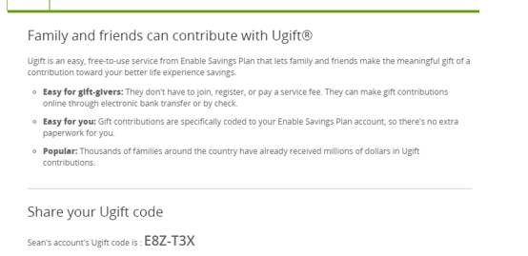

**They can then give the following info to friends and family to contribute:**